**2016 RIO OLYMPICS**

# **TOP 3 COUNTRIES**

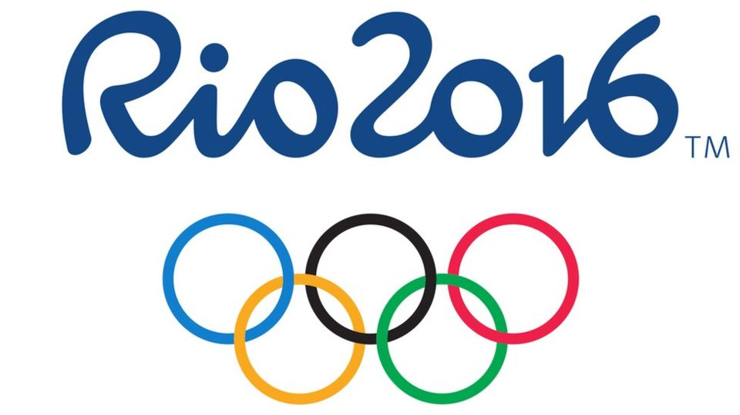

(CLICK ON IMAGE FOR SOURCE)

|  |  |  |
| --- | --- | --- |
| **1****UNITED STATES** | **2****GREAT BRITAIN** | **3****CHINA** |
| |  |  |  |  |  | | --- | --- | --- | --- | --- | | MEDALS BY GENDER | | | | | | GENDER | GOLD | SILVER | BRONZE | TOTAL | | FEMALE | 27 | 17 | 17 | 61 | | MALE | 18 | 18 | 20 | 56 | | MIXED | 1 | 2 | 1 | 4 | | TOTAL | 46 | 37 | 38 | 121 | | |  |  |  |  |  | | --- | --- | --- | --- | --- | | MEDALS BY GENDER | | | | | | GENDER | GOLD | SILVER | BRONZE | TOTAL | | FEMALE | 8 | 9 | 8 | 25 | | MALE | 19 | 13 | 9 | 40 | | MIXED | 0 | 1 | 0 | 1 | | TOTAL | 27 | 23 | 17 | 67 | | |  |  |  |  |  | | --- | --- | --- | --- | --- | | MEDALS BY GENDER | | | | | | GENDER | GOLD | SILVER | BRONZE | TOTAL | | FEMALE | 14 | 11 | 16 | 66 | | MALE | 12 | 7 | 9 | 28 | | MIXED | 0 | 0 | 1 | 1 | | TOTAL | 26 | 18 | 26 | 70 | |